**ESSAY**

1. The main function of maintaining database security : To protect databases from any big or small threats and risks, intentional or accidental like malicious, breaches, hackers, virus, theft, etc. So, databases are protected, have a great privacy, integrity, etc. Not only databases, this security affects to the hardware, software, and people.

Steps that can be taken to do that :

* Grant the access to specific persons and protect them from outsiders
* Don’t access the suspicious link that will lead you to phising, money laundering offer, suspicious apps, etc.
* Prepare the backup in any situation (backup the data and prepare the electricity replacement)
* Check the credibility of every chats and calls from outsiders to prevent the suspicious things
* Check physical databases location like adding cameras, locks, or staff security
* Install proxy server to database that encrypts data travelling
* Encrypt them using the strong-complicated password
* 2FA
* Use firewalls and antivirus (subscribe to features are extremely recommended)
* Always update your application

Reference :

Fanchi, C. (2021, December 10). 8 critical database security best practices to Keep Your Data Safe. Backendless. Retrieved July 12, 2022, from https://backendless.com/database-security-best-practices/

tripwire. (2021, February 24). 10 database security best practices you should know. The State of Security. Retrieved July 12, 2022, from https://www.tripwire.com/state-of-security/featured/database-security-best-practices-you-should-know/

1. tripwire. (2021, February 24). 10 database security best practices you should know. The State of Security. Retrieved July 12, 2022, from https://www.tripwire.com/state-of-security/featured/database-security-best-practices-you-should-know/ Join and Union
2. Join : Combining two different tables and forming the rows into one table and the other selected table becoming the new column rather than combined into rows.

Example :

select c.CustomerID, CustomerName, a.AgentID, AgentName from

MsCustomer c

join HeaderTransaction ht on ht.CustomerID = c.CustomerID

join MsAgent a on a.AgentID = ht.AgentID

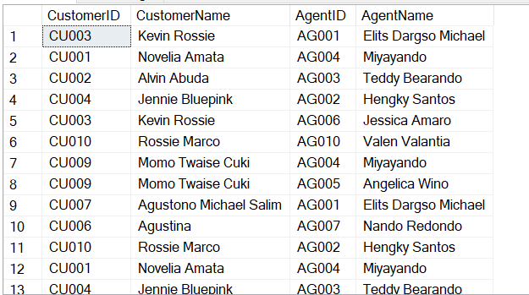

1. Union : Combining two tables (either same or different) and containing all rows from them into a lot of rows

Example :

select CustomerID, CustomerName from

MsCustomer

union

select AgentID, AgentName from

MsAgent

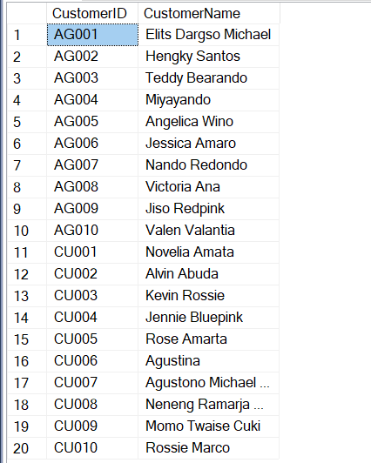

Connolly T., & Begg C. (2015). Database Systems: A Practical Approach to Design, Implementation, and Management, Global Edition. [VitalSource Bookshelf]. Retrieved from <https://online.vitalsource.com/#/books/9781292061849/>

1. Data warehouse characteristics :

* Subject-oriented data : organized around any roles of the enterprise (customers, products, and sales) rather than application areas (invoicing, stock, product, etc.) to make various decisions.
* Integrated Data : integrating data from any sources of data (mainframe and relational), but that data mostly are inconsistent. So, labelling, codes, and formats are important for analysis of the data.
* Time-variant data : update, alter, or modify are normal things in managing database and needs the proof with timing. Time is so different and has variants to maintain the data implicit or explicit
* Non-volatile data : data got refreshed by OS rather than real-time update. Data also is read-only for analytics.

References :

Connolly T., & Begg C. (2015). Database Systems: A Practical Approach to Design, Implementation, and Management, Global Edition. [VitalSource Bookshelf]. Retrieved from <https://online.vitalsource.com/#/books/9781292061849/>

Sharma, M. (2018, October 22). Characteristics and functions of Data Warehouse. GeeksforGeeks. Retrieved July 12, 2022, from https://www.geeksforgeeks.org/characteristics-and-functions-of-data-warehouse/

**CASE**

1. Sales Normalization

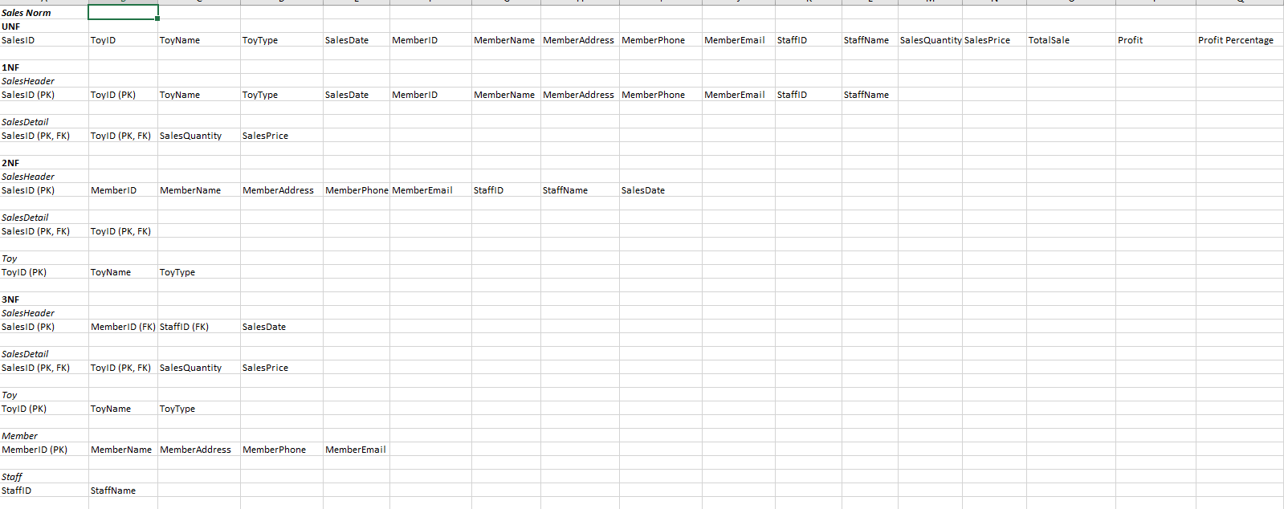

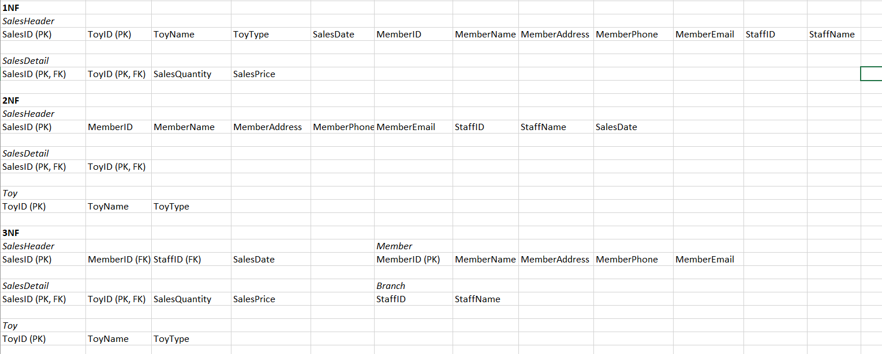

Purchase Normalization

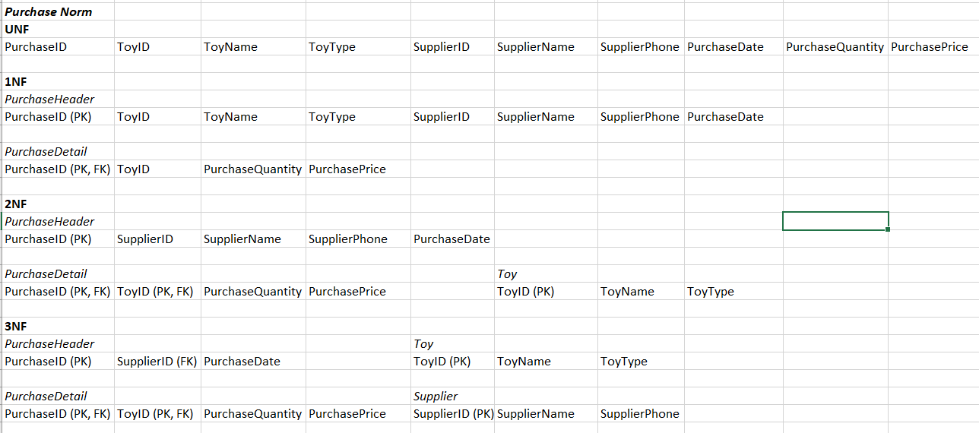

1. ERD

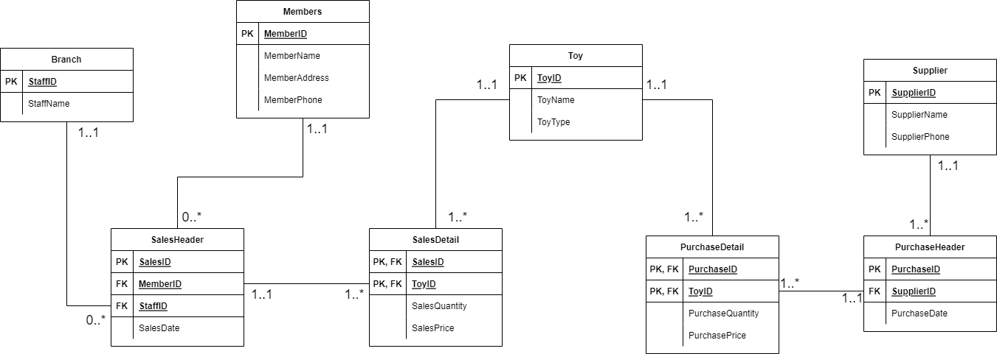

Toy table are the one with multiplicity because it connects with sales and purchases table

Before we continue to No. 6 – 8, let me give you the Create-Insert Query Screenshots

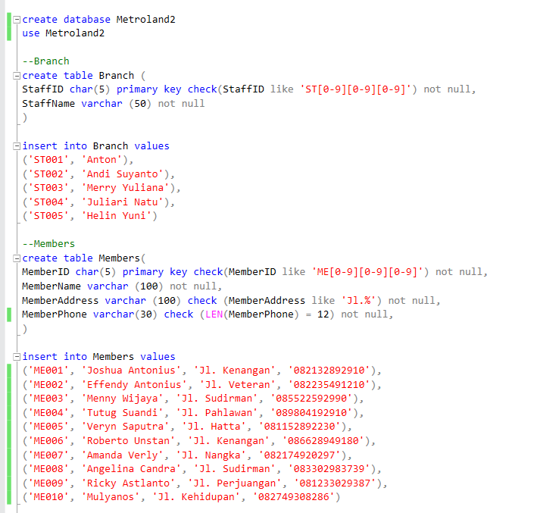

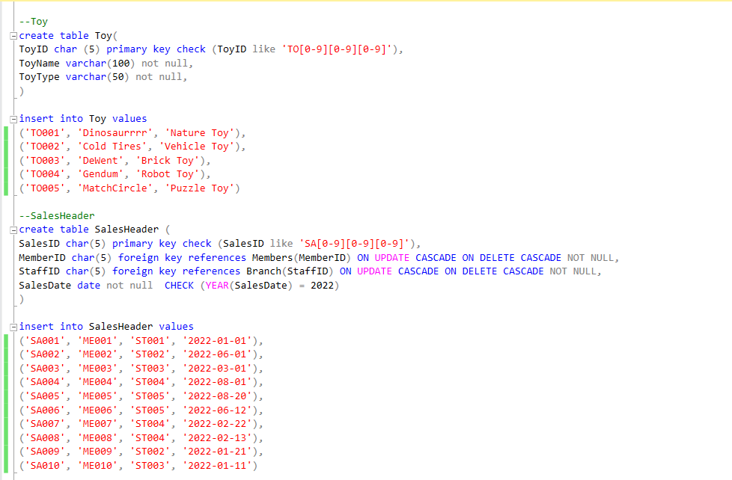

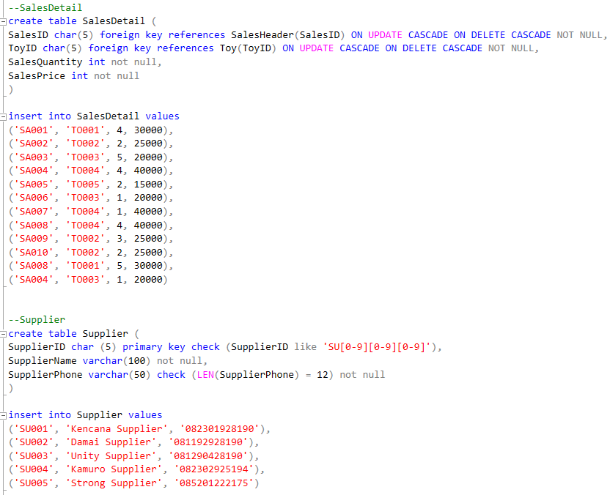

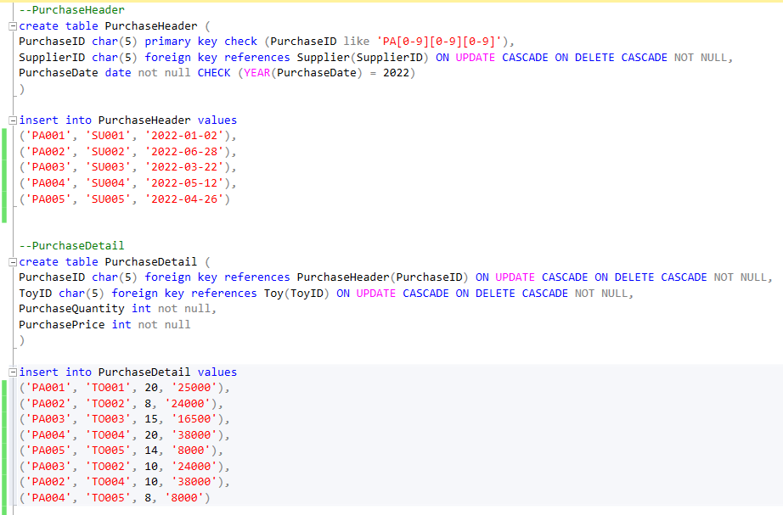

1. Please create a profitability report of sales transaction during the period Jan – Mar 2022. The report will show some require fields quantity of each sold toys type, purchase price, sales price, profit for each type, and the profitability percentage.

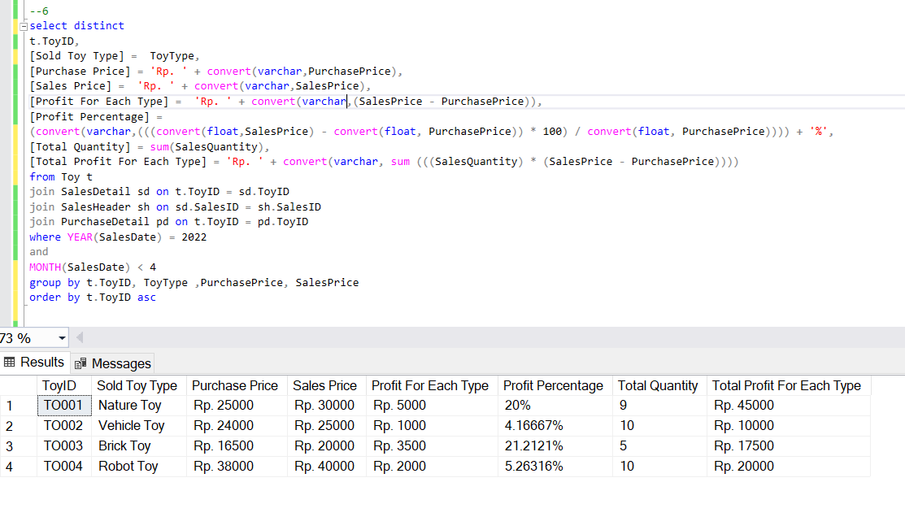

All of the 4 types of toys are in the sales process on January until March. Use distinct to eliminate the multiple data.

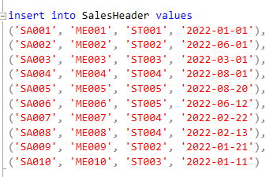

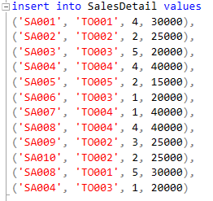

SalesID that did transaction in January – March 2022 :

1. SA001 (TO001)
2. SA003 (TO003)
3. SA007 (TO004)
4. SA008 (TO004 & TO001)
5. SA009 (TO002)
6. SA010 (TO002)

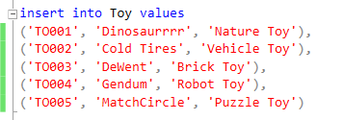

Conclusion, toy types that included here are : TO001, TO002. TO003, TO004

1. Please create a report using subquery to show items that have not sold during Jan – Mar 2022

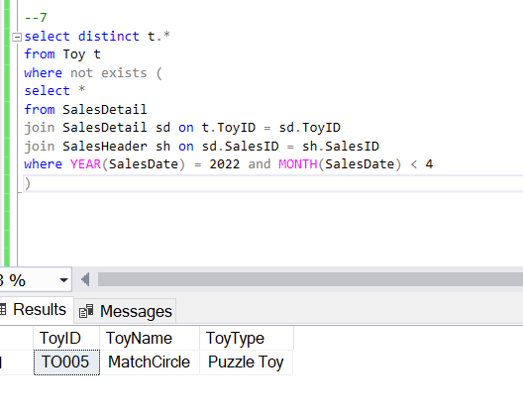

Here’s why TO005 showed up :

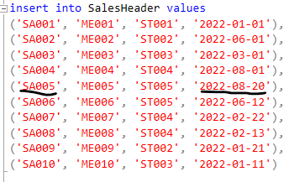

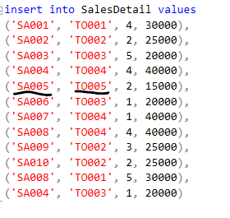

As I underline it, TO005 sales happened on August only and no sales on January until March.

1. Display Customer Data

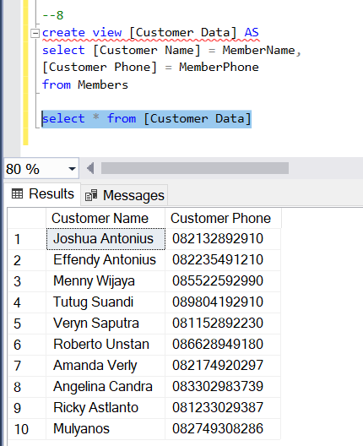

Video link : <https://youtu.be/JTKYDZW3LDw>